Benjamin Berger

Bberger3@bing

Purpose was to learn about different edge detection methods.

Methods used were mean filters, medium filters, sobel masking, unsharp masking, Laplacian of Gaussian.

Results at the bottom of document.

Used things like Wikipedia, Brads skeleton, and http://homepages.inf.ed.ac.uk/

Part 1

1)

M4, M3, M1, M2

Because M4 will have a multiplier of 1, which means that nothing changes. From there is goes down to 1/8, 1/9, and then 1/16.

2) The second will be better for image enhancement because it is more sensitive to edges.

3) Just run through it generating the image like LoG.

4) Applying the edge detection first is probably best, otherwise you may lose some of the edges when the image is blurred.

5) a)

4 4 4 4 4 4 4 4

4 4 4 4 48 4 4 4

4 4 4 64 64 64 64 4

4 4 17 64 64 64 64 4

4 4 4 64 64 64 64 4

4 4 56 64 64 64 8 4

4 4 56 4 4 23 4 4

4 4 4 4 4 4 4 4

b)

4 4 4 4 4 4 4 4

4 4 4 4 4 4 4 4

4 4 4 4 4 4 4 4

4 4 4 4 64 48 4 4

4 4 17 64 64 4 23 4

4 4 4 64 64 8 4 4

4 4 4 64 64 4 4 4

8 4 4 4 4 4 4 4

c) the cross filter is better cause with the 3x3 everything gets bunched up and you lose edges.

Part 2

1. run ./p2-1 img1 img2 to show images
2. run ./p2-2 img1 img2 to show images. Spacebar to cycle. Don’t think this really worked.

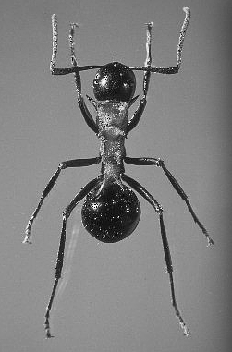

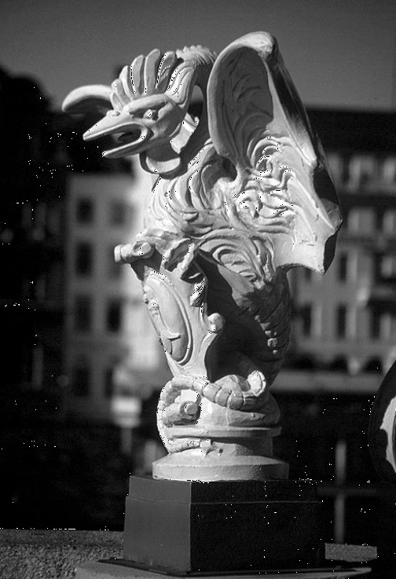

1. run ./p2-3 img1 img2

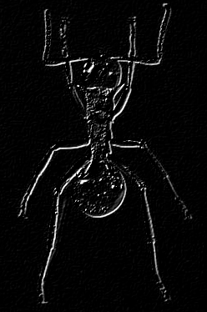

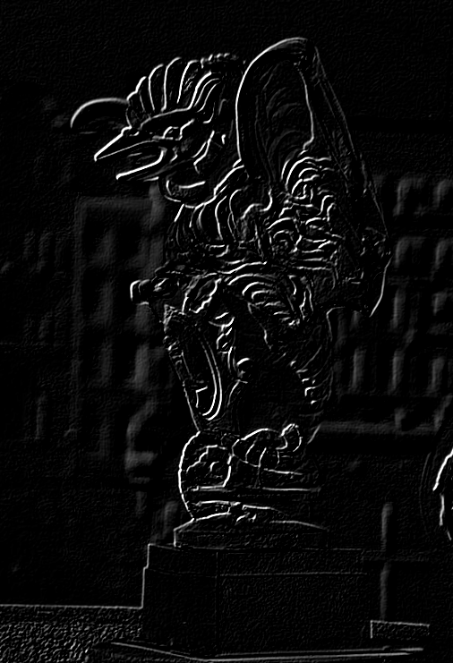

1. (and 5) run ./p2-4 img1 img2 Press space bar to cycle the masks

7x7

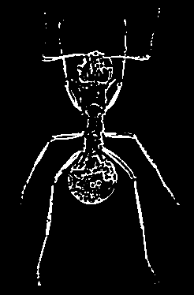

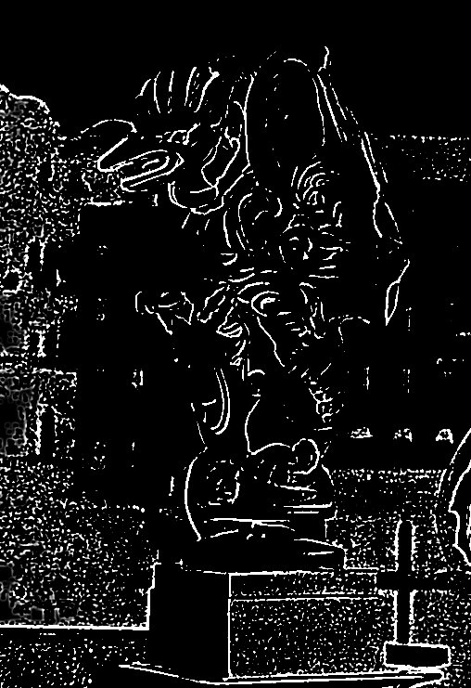

mask 11x11

